ASSIGNMENT - DIGITAL MARKETING

|  |  |
| --- | --- |
| Reg No | 962820106031 |
| NAME | SELVA POOJA. A. T |
| NM ID | 697EC09780CB494AEE34F069F043F9EA |
| Date | 20-10-2023 |

1.Create a blog or website using Blogspot and WordPress. Customize the theme design and post new article with 500 words.

Link: https://www.blogger.com/blog/posts/3482539583518227921

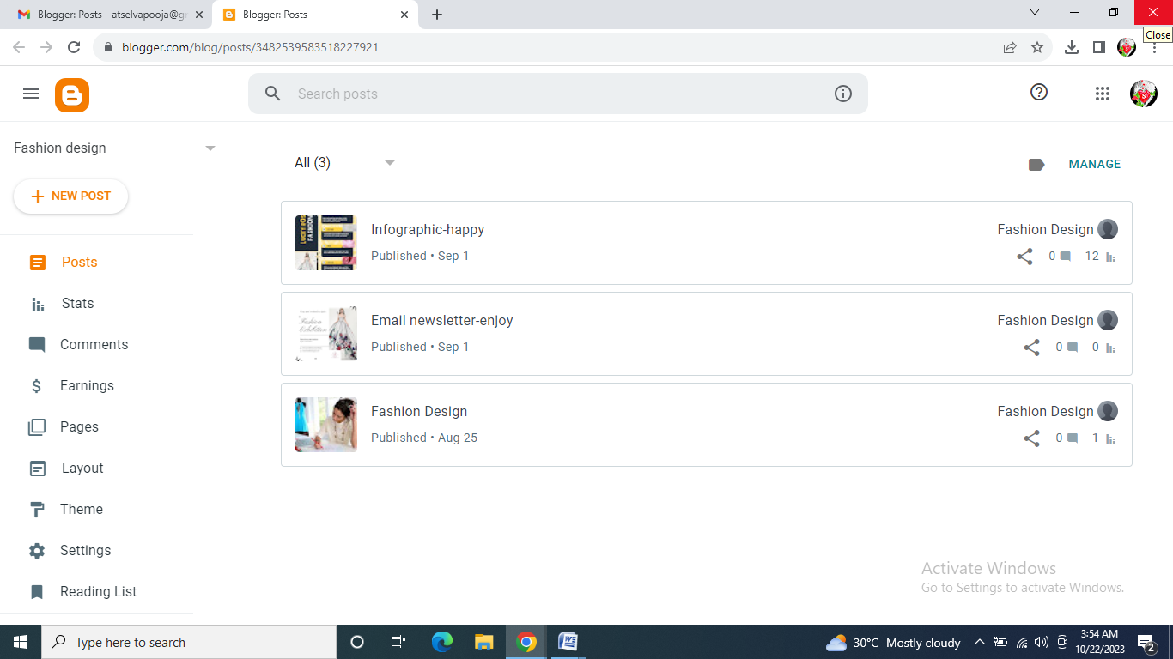

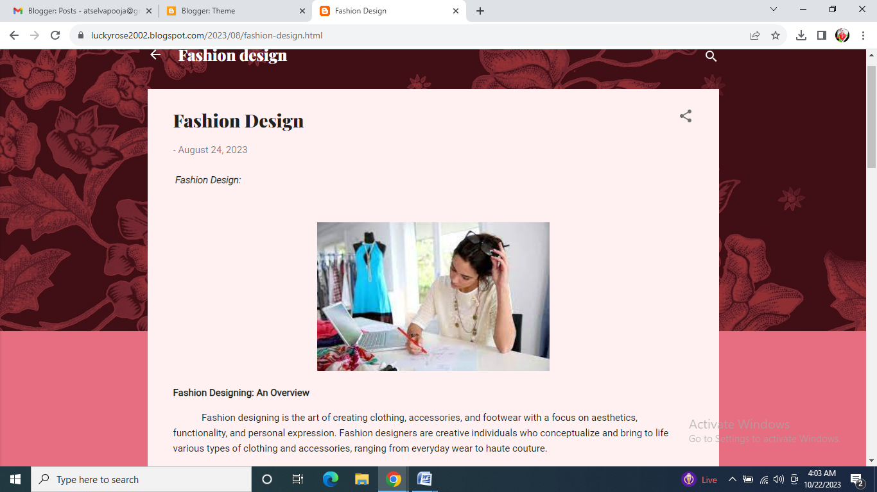

**2**.Create a new facebook page and post one social media poster for your brand.

Link: https://www.facebook.com/profile.php?id=61551946357200

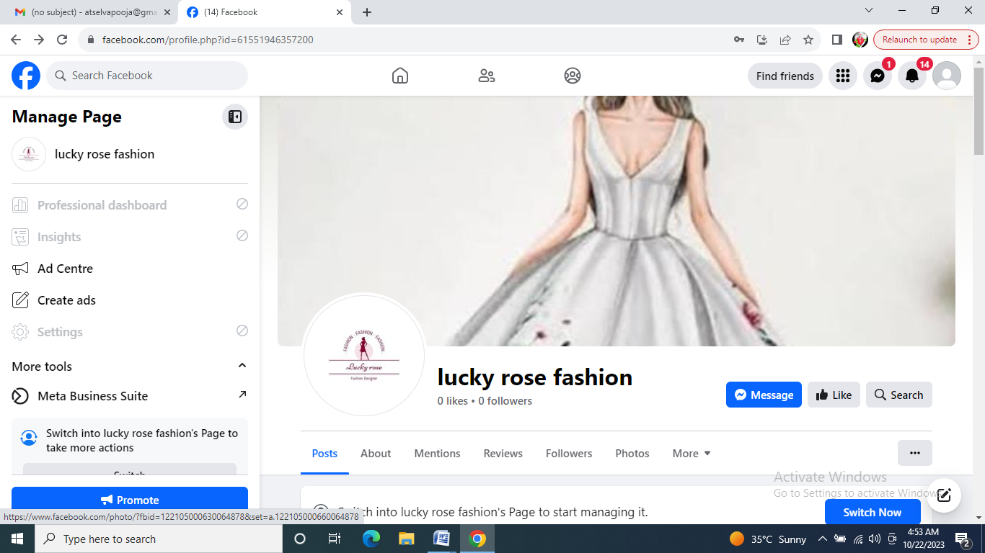

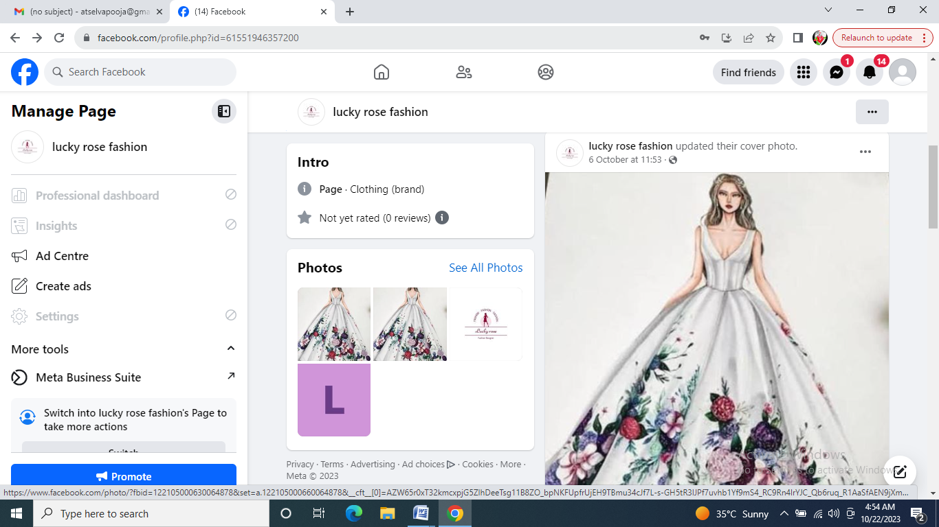

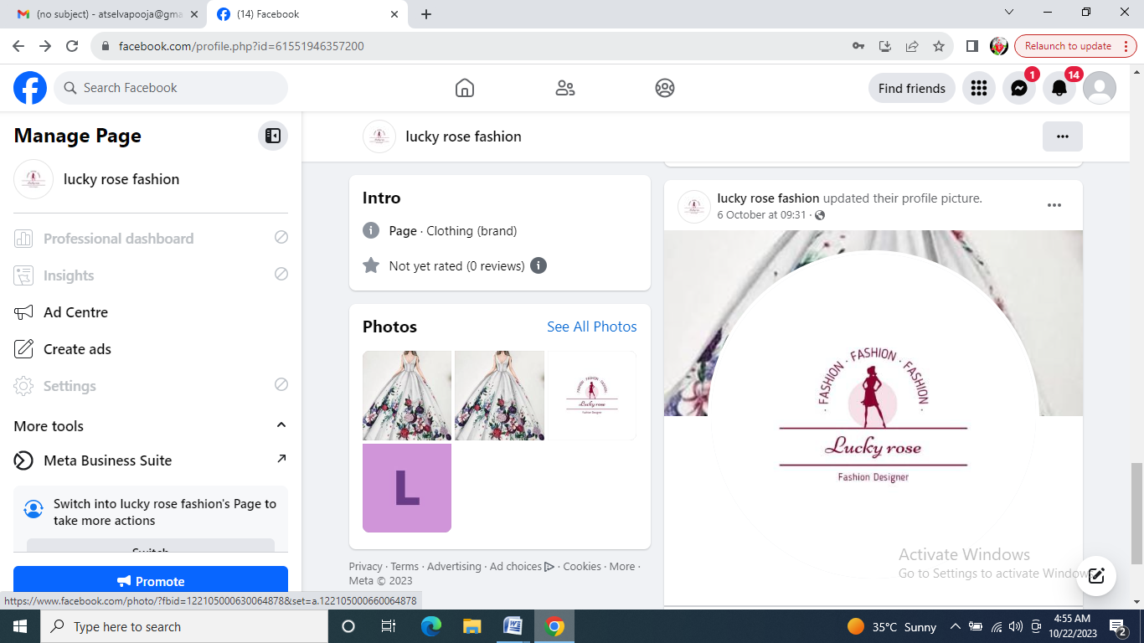

**3**.Create and design a social media advertisement poster using canva

Link: https://www.canva.com/design/DAFx-4EnJO8/59n8BLY0ojcrLxvBs83W8A/edit



4.Create email newsletter design using MailChimp or canva tool.

Link:Using canva

<https://luckyrose2002.blogspot.com/2023/09/email-newsletter-enjoy.html>

